# Source Control History

|  |  |
| --- | --- |
| Date | Evidence |
| 26/11/2020 (Thursday) | Ref 1 |
| 27/11/2020 (Friday) | Ref 2 |
| 30/11/2020 (Monday) | Ref 3 |
| 01/12/2020 (Tuesday) | Ref 4 |
| 02/12/2020 (Wednesday) | Ref 5 |

Ref 1

1. 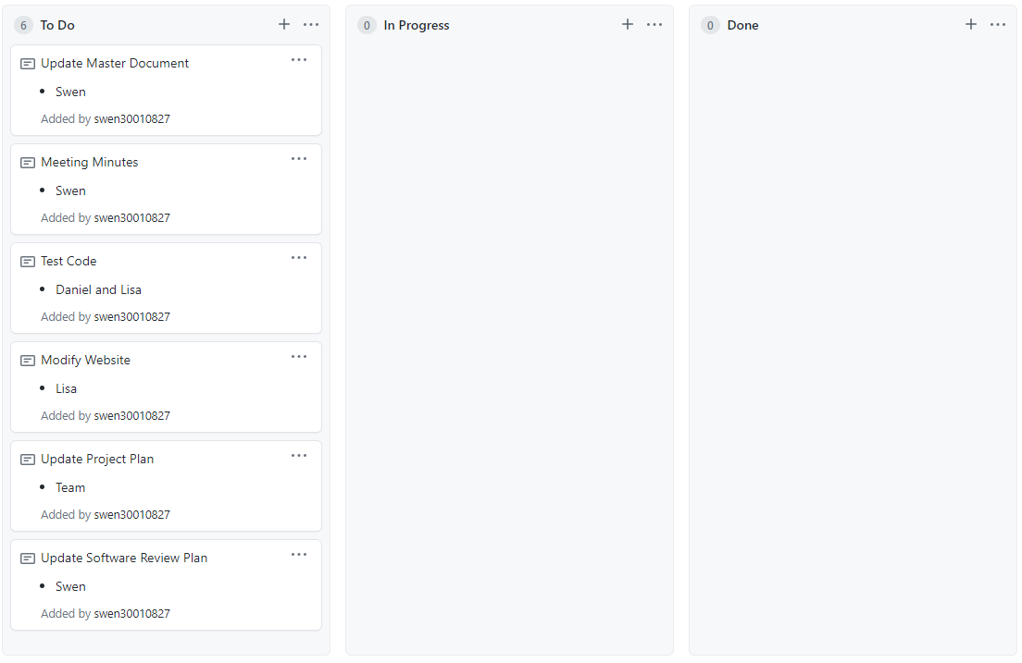
2. 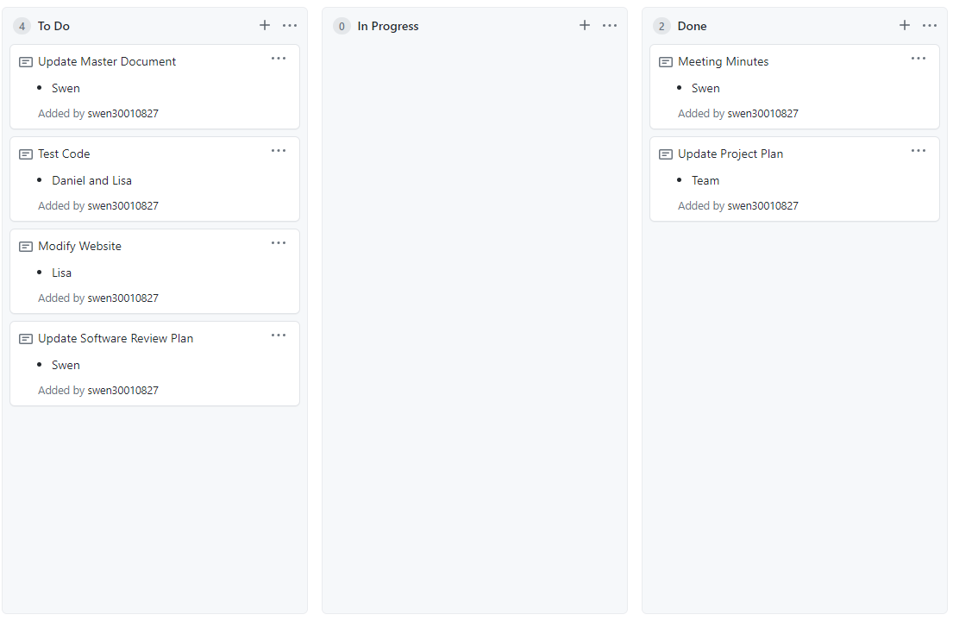

Ref 2

1. 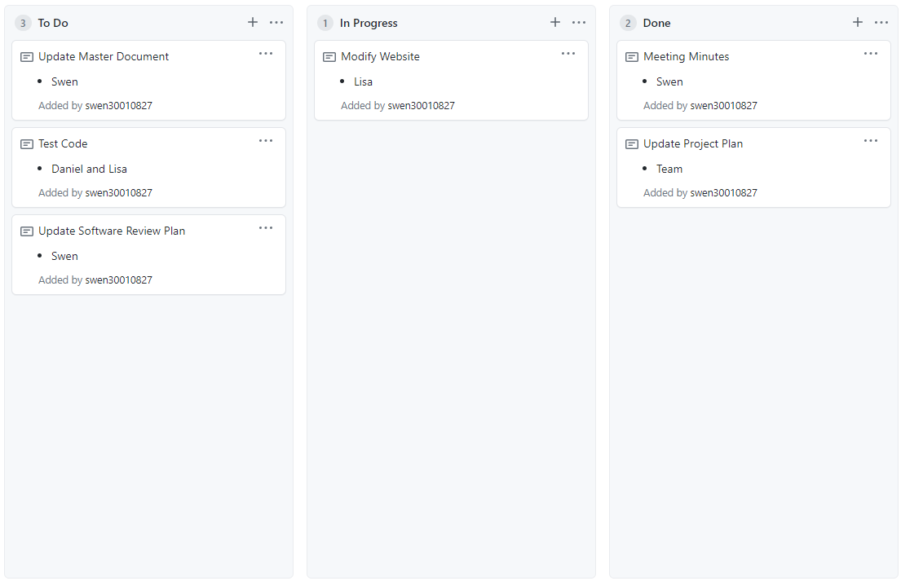

Ref 3

1. 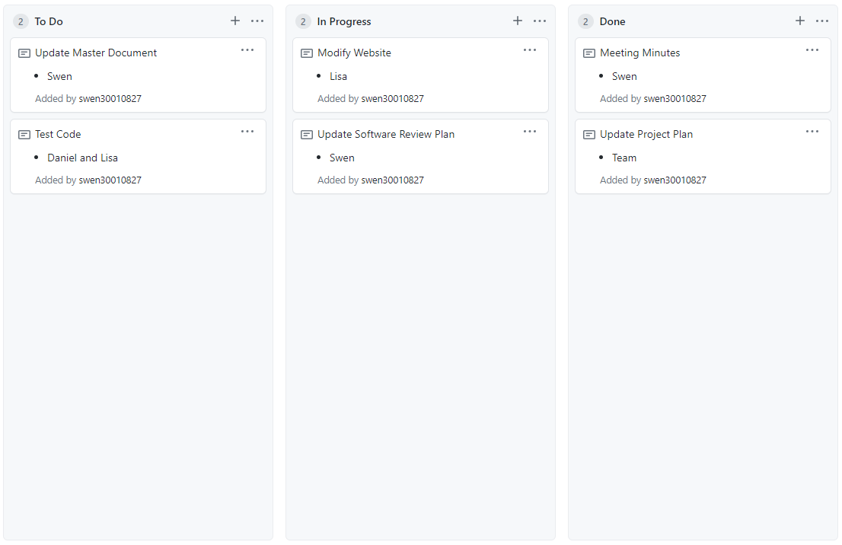

Ref 4

1. 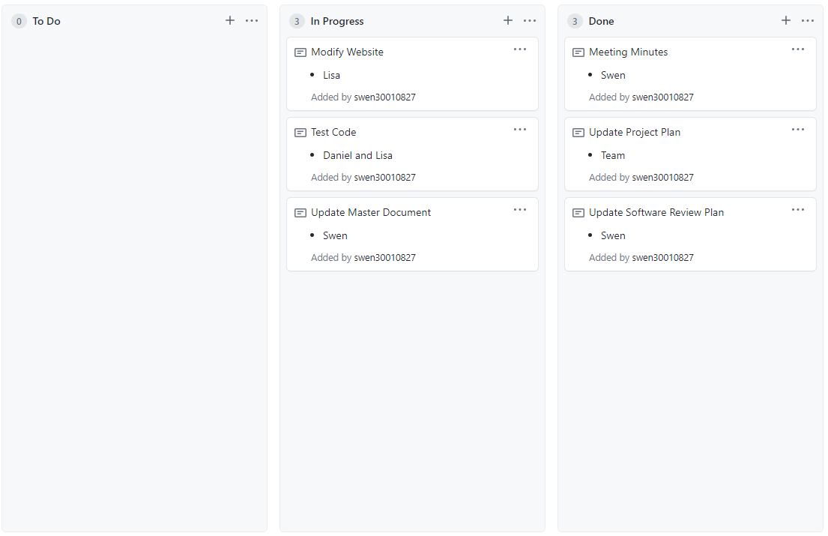

Ref 5

1. 